# 1 Day Cycling

**Highlight of this tour : Exciting Cycling, primary forest, Amazing views, wildlife and authentic villages**

**Difficulty: Moderate**  
**Departure: Daily at 8:30 AM**

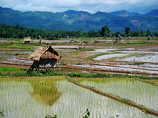

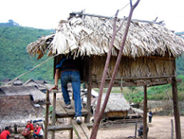

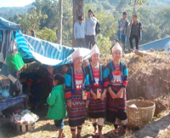

# Trip Overview:

This incredible day will include up to 6 hours of cycling, with lots of incredible stops. An alternative and easy way to explore the beautiful scenery of the town of Lung Namtha. Scenic views of the river bank, waterfall and visit minority villages (Hmong, Lantan, Khmu, Labed, Phounoi, Taidam and Akha ) along the dirt road. Trained guides will share information about the ecology and culture.

# Itinerary:

8:30 Am - Arrive to the office to prepare. 9:00 Am - Meet with guide and leave office by Tuk-Tuk for about 30 minutes

* Visit Luang Namtha traditional museum to see local products (except weekends).
* Learn about traditional bamboo paper making (in winter), dying fabrics with plants as natural dyes, weaving
* See how local Lao Lao whisky is made and sample some, and see the first ever Lanten museum and library.
* Be enchanted by the extensive rice paddy vistas, and see two different temples.
* This tour is also available as a tuk tuk or minivan tour - pricing starts at $31pp for this option.

A small green rectangle to divide sections of the document

# Things to Bring:

Please bring good walking shoes, long sleeve T-shirt, warm sweater, long pants, hat, sunscreen, mosquito repellents, camera, medicines, snack food, and money to purchase handicrafts.

A small green rectangle to divide sections of the document

# 

# Price includes:

Experienced guide, tour permit and village conservation fund, local government taxes, food, and first aid kit.

# Price:

|  |  |  |  |  |  |  |  |
| --- | --- | --- | --- | --- | --- | --- | --- |
| Amount of People | 2 | 3 | 4 | 5 | 6 | 7 | 8 |
| Price/Kip | 300.000 | 270.00 | 250.000 | 230.000 | 220.000 | 210.000 | 200.000 |
| Price/dollar | 35 | 33 | 30 | 28 | 25 | 24 | 23 |

# Where does your Money go?

